Title
Name Surname, Name Surname
Affiliation, City, Postal Code, Country
Corresponding E-mail:*****************

Abstract
The abstract section should describe the objectives, the methodology and the main conclusions in about 200 words. It should not contain equations or references to bibliography.
The extended abstracts should have a maximum of 2 pages (it is suggested 1 page) including the results, figures, equations, acknowledgments and references.
Introduction
The extended abstracts and final papers must be formatted strictly according to these instructions. The present file can be used as a template for MSWord users.
Experimental or Numerical Methods, etc.
You can describe in this section, your experimental facility, numerical methods, etc. You can change the title of this and other sections to fit the text. You can also include figures, equations, etc.
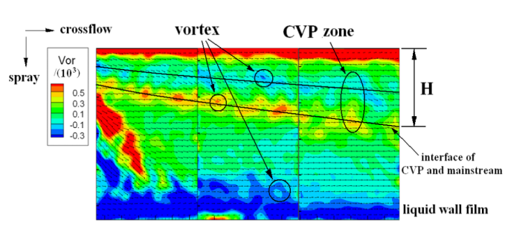
Figure 1: Place here the figure caption.(example of figure)
Equations
No blank line is included above and below each equation.
(1)
Citations
Please list the references following the examples in the end of this template (Manglik 2004; Hoffmann and Stein, 2002).
Results and Discussion
You can change the title of the section, and you can include figures and tables. Discuss briefly your results.
Figure 2: Place here the figure caption.(example of figure)
Conclusions
Describe briefly in this section the main conclusions of your work.
Acknowledgments
This optional section must be placed before the list of references.

References
Manglik R.M., Swirl flow heat transfer and pressure drop with twisted-tape inserts, Adv. Heat Transfer, Vol. 36 pp. 183-265 (2004)
Hoffmann A.C., Stein L.E., Gas cyclones and swirl tubes: principles, design, and operation. Springer-Verlag, Berlin, Germany (2002)

Please select a submission topic
Options | Topic
 | 1. Interfacial phenomena & mechanisms
 | 2. Multiphase flow and heat transfer
 | 3. Reactive multiphase flow
 | 4. Modeling and numerical methodologies
 | 5. Measurement and instrumentation
 | 6. Multiphase flow in industrial process
 | 7. Resource exploitation (rare-earth, oil & gas)
 | 8. Organic waste conversion and utilization
 | 9. Hydrogen production and utilization
 | - Low carbon technology and new energy
- Interdisciplinary multiphase flow (medicine, bionic, ...)

